Neural Network fundamentals with TensorFlow

# Course Outline

## Tensorflow Basics

* Creation, Initializing, Saving and Restoring TensorFlow variables
* Feeding, Reading and Preloading TensorFlow data
* How to use TensorFlow infrastructure to train models at scale
* Visualizing and Evaluating models with TensorBoard

## TensorFlow Mechanics

* Inputs and Placeholders
* Build the Graph
  + Inference
  + Loss
  + Training
* Train the model
  + The graph
  + The session
  + Train loop
* Evaluate the model.
  + Build the eval graph
  + Eval output

## The perceptron

* Activation functions
* The perceptron learning algorithm
* Binary classification with the perceptron
* Document classification with the perceptron
* Limitations of the perceptron

## Support Vector Machines

* Kernels and the kernel trick.
* Maximum margin classification and support vectors

## Artificial Neural Networks

* Nonlinear decision boundaries
* Feedforward and feedback artificial neural networks
* Multilayer perceptrons
* Minimizing the cost function
* Forward propagation
* Back propagation
* Improving the way neural networks learn

## Convolutional Neural Networks

* Goals
* Model architecture
* Principles
* Code organization
* Launching and training the model.
* Evaluating a model.

# TensorFlow Basics.

## What is TensorFlow?

TensorFlow is an open source library and application programming interface (API) for building programs that employ machine learning for a range of tasks. Components of TensorFlow include a symbolic math library as well as interfaces for building and training machine learning applications to detect and decipher patterns and correlations in data. This is similar to the way that biological entities learn and reason.

TensorFlow was created and made available by Google, Inc and was released under the Apache 2.0 Open Source License on 9 November, 2015.

TensorFlow was based on an earlier system, also built at Google called DistBelief. DistBelief gained increasing popularity among Google’s (Later Alphabet) different companies and divisions for use in both commercial and research applications. Google spent significant resources to simply and refactor the code base of DistBelief into a robust, performant applications-grade library which was then called TensorFlow. Version 1.0.0 of TensorFlow was released on 11 February 2017. TensorFlow can run on single or multiple CPU’s and GPU’s. TensorFlow is available on 64 bit Linux, MacOS, Windows and mobile platforms including iOS and Android.

TensorFlow provides a number of programmatic API’s for various computer languages, including Python, C++, Java, GoLang and Rust.

Additionally, third party API’s are available for C#, Julia, R and Scala.

TensorFlow is known for use in image processing and recognition, deep learning with AlphaGo and other cutting edge applications in the field of Machine Learning.

## How does TensorFlow work?

TensorFlow computations are expressed as stateful dataflow graphs. The name TensorFlow derives from the operations that these neural networks and other machine learning algorithms perform on multidimensional data arrays, known as *tensors*.

Tensors are formally known as mutilinear maps from vector spaces to real numbers, so, for example,

* A scalar is a tensor
* A vector is a tensor
* A matrix is a tensor

Basically, tensors can be represented as a multidimensional array of numbers.

### TensorFlow vs. Numpy

TensorFlow and Numpy are similar. Both are N-d array libraries. While Numpy has Ndarray support, it doesn’t offer methods to create tensor functions and automatically compute derivatives. Additionally, numpy offers no support for using GPU’s, unlike TensorFlow.

Let’s take a look at a similar program using both standard Python with Numpy and a TensorFlow application.

Table . A simple numpy program.

|  |
| --- |
| #!/usr/bin/env python3  import numpy as np  # Create an array 'a' as a 2 by 2 dimensional array  # initialized to zeros.  a = np.zeros((2,2))  # Create an array 'b' as a 2 by 2 dimensional array initialized to  # ones.  b = np.ones((2,2))  # Add the two up. The axis parameter refers to columsn vs. rows.  # axis=0 refers aggregation along the row, axis=1 refers to  # aggregation along the columns.  print (np.sum (b,axis=1))  # The reshape method changes a to be a 1 X 4 array.  print (np.reshape(a,(1,4))) |

Now let’s take a look at the same program using TensorFlow.

Table *. A* simple TensorFlow example.

|  |
| --- |
| #!/usr/bin/env python3  import tensorflow as tf  # Running in interactive mode is good for debugging as it  # executes the tensorflow code straight away rather  # than having to create a session variable.  tf.InteractiveSession()  # Create our 'a' array as a 2 X 2 tensor initialized to zeros.  a = tf.zeros((2,2))  # Create our 'b' array as a 2 X 2 tensor initialized to ones.  b = tf.ones((2,2))  # Sum array a and b, reduction_indices is similar to 'axis'.  # note that we have to invoke the eval() method to  # actually get the reduce_sum method to run.  print (tf.reduce_sum(b,reduction_indices=1).eval())  # Print the shape of tensor 'a'.  print (a.get_shape())  # Reshape 'a' as a 1 X 4 tensor and print it out.  print (tf.reshape(a,(1,4)).eval()) |

Following is a table of Numpy vs. TensorFlow statements for the previous examples.

Table . A summary of differences between Numpy and TensorFlow statements.

|  |  |
| --- | --- |
| **Numpy** | **TensorFlow** |
| a = np.zeros((2,2)); | a = tf.zeros((2,2)) |
| b = np.ones((2,2)) | b = tf.ones((2,2)) |
| np.sum(b, axis=1) | tf.reduce_sum(a,reduction_indices=[1]) |
| a.shape | a.get_shape() |
| np.reshape(a, (1,4)) | tf.reshape(a, (1,4)) |
| np.dot(a,b) | tf.matmul(a, b) |
| b * 5 + 1 | b * 5 + 1 |
| a[0,0], a[:,0], a[0,:] | a[0,0], a[:,0], a[0,:] |

Note that TensorFlow requires explicit evaluation of operations. A big difference between the two is that the TensorFlow variables have no actual value until the TensorFlow operation is evaluated. What you will get when printing a tensorflow variable before execution is something like this:

Table . Output of a tensor variable before execution of the graph.

|  |
| --- |
| Tensor("zeros:0", shape=(2, 2), dtype=float32) |

This is what will happen in our simple TensorFlow example if you insert a print (a) in the code before you invoke the tf.reduce_sum evaluation method.

### The TensorFlow session.

The TensorFlow documentation defines a session object as: “A Session object encapsulates the environment in which Tensor objects are evaluated.”

Let’s see how this would work.

Table . A simple example of using sessions in TensorFlow.

|  |
| --- |
| #!/usr/bin/env python3  import tensorflow as tf  # Here we declare two constants.  a = tf.constant (5.0)  b = tf.constant (6.0)  # Multiply the two tensors together to output a third tensor 'c'.  c = a * b  # Nothing will run until we start a TensorFlow session.  # In the previous example, tf.InteractiveSession() was just  # syntactic sugar for the following.  # Note that we can use the Python 'with' to treat tf.Session  # as a context object, containing __entry__ and __exit__ methods.  with tf.Session() as sess:  # Note that c.eval() is, again, syntactic sugar for the sess.run(c)  # statment. sess.run() is an exxample of a Tensorflow fetch  # statement.  print (sess.run(c))  print (c.eval()) |

### The TensorFlow Computation Graph.

TensorFlow programs are structured as follows:

* A construction phase, which creates and assembles a graph.
* An execution phase, used to run operations inside the graph.

When training a TensorFlow model, we use variables to hold and update parameters. Variables are in-memory buffers that contain tensor objects.

Up until now, all the tensors we’ve seen have been constants, not variables. Let’s see how tensor variables work.

Table . The TensorFlow variable.

|  |
| --- |
| #!/usr/bin/env python3  import tensorflow as tf  W1 = tf.ones((2,2))  # Note that W2, unlike W1, is a node in the TensorFlow Graph.  # The name parameter is useful when we want to save or restore  # the values of the variable from a file.  W2 = tf.Variable(tf.zeros((2,2)),name='weights')  with tf.Session() as sess:  print ('\nW1')  print (sess.run(W1))  # Here we initialize all of the graph variaables.  sess.run(tf.global_variables_initializer())  # We have to run the graph in order to gain access to W2 to print it.  print ('\nW2')  print (sess.run(W2)) |

As noted previously, TensorFlow variables *must* be initialized via the global_variables_initializer() method before they will hold any values.

To change the value of a TensorFlow variable we can use the tf.assign() method as follows:

Table . Changing TensorFlow variable state.

|  |
| --- |
| state = tf.Variable(0,name-=’counter’)  new_value = tf.add(state, tf.constant(1) # This is equivalent to new_value = state + 1  update = tf.assign(state,newvalue) # Assign the value of new_value back to state.  with tf.Session() as sess:  sess.run(tf.global_initialize_variables())  print (sess.run(state))  for _ in range(3):  sess.run(update)  print (sess.run(state)) |

The output of this program should be the values, 0,1,2,3.

### Fetching Variable State.

Calling the run(var) method on the TensorFlow session object and passing in a TensorFlow variable name will result in a *fetch* operation. Note that multiple variables can be passed to the run method. The state of each variable will be fetched and stored in a standard Python variable.

For example:

Table . Fetching TensorFlow variables.

|  |
| --- |
| input1 = tf.constant(3.0)  input2 = tf.constant(2.0)  input3 = tf.constant(5.0)  intermed = tf.add(input2, input3)  mul = tf.mul(input1, intermed)  with tf.Session() as sess:  # Fetch the mul and intermed variables  result = sess.run([mul, intermed]) print(result) |

The TensorFlow graph for this operation appears as follows:

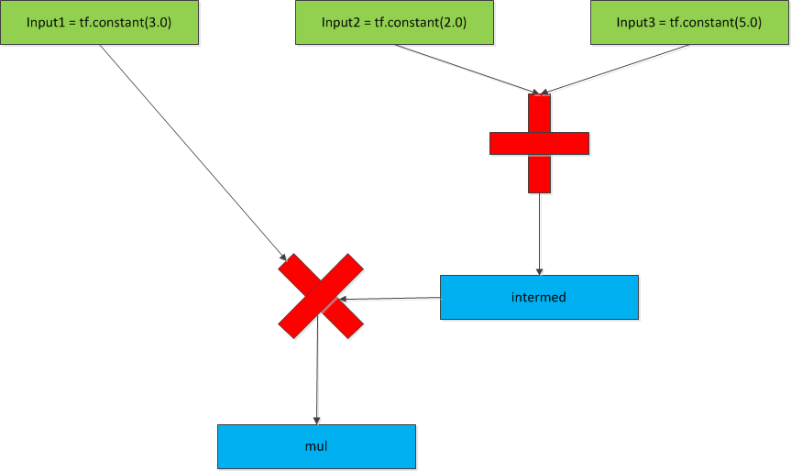

### Inputting data into a TensorFlow graph.

Up to now, we’ve defined our tensors manually. However, in nearly all cases, most data will be loaded via external sources. We can do this in several ways.

* By using the numpy library to create data and then convert it to a TensorFlow tensor.
* By creating a tf.placeholder variable and then feeding data to it via a dictionary.

The second way is by far the most preferable method, since method one doesn’t scale well to large data sets.

Here is an example of both methods.

Table . Using TensorFlow placeholders.

|  |
| --- |
| import numpy as np  import tensorflow as tf  # Method 1. Converting a numpy array to a tensor.  a = np.zeros((3,3))  ta = tf.convert_to_tensor(a)  with tf.Session() as sess:  print (sess.run(ta))  # Method 2. Using a placeholder.  # Here we declare a placeholder as a 32 bit floating point value.  input1 = tf.placeholder(tf.float32)  input2 = tf.placeholder(tf.float32)  output = tf.mul(input1, input2)  with tf.Session as sess:  print (sess.run([output], feed_dict = {input1:[7.], input2: [2.]})) |

The graph for the above program looks like this:

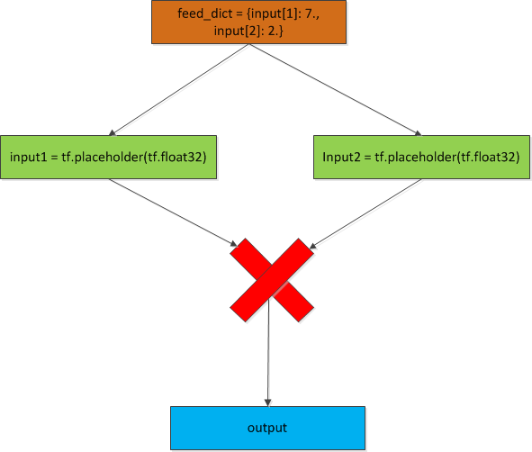

### TensorScope Variable Scoping.

In a complex system, a TensorFlow model can have hundreds of different variable. This means that the possibility for name clashes (i.e. two variables both called ‘foo’) increases. TensorFlow allows us to sidestep this problem by providing namespaces for variables. For example:

|  |
| --- |
| with tf.variable_scope("foo"):  with tf.variable_scope("bar"):  v = tf.get_variable("v", [1])  assert v.name == "foo/bar/v:0" |

Here we see that we have two variables scopes, ‘foo’ and ‘bar. bar is a nested scope underneath foo. Therefore any variable declared in the ‘bar’ scope will have a fully qualified name of ‘foo/bar/v’

Note that an optional parameter to the tf.variable.scope() method is variable_reuse = True. This allows for variables to be re-used as necessary. This can be required when implementing Recurral Neural Networks.

# Linear Regression with TensorFlow.

In machine learning and statistics, Linear Regression is the modeling of the relationship between a variable such as Y and at least one independent variable as X. In the linear regression, the linear relationships will be modeled by a predictor function which its parameters will be estimated by the data and is called a Linear Model. The main advantage of Linear Regression algorithm is it’s simplicity and ease of implementation. The biggest disadvantage of Linear Regression is the fact that it only works on data that is linearly correlated, that is, there is a linear relationship between one or more independent variables and the dependent variable.

Here we see an example of some linear data plotted along an x/y coordinate axis plane.

With linear regression, we try and find a ‘best fit’ line that has the least amount of error.

Note here that we have drawn a ‘best-fit’ line through the points so that if we know the line’s equation, we can now use it to predict a new housing price, say, for the value 2.5.

The linear regression model has the following components.

1. The linear equation model algorithm for our linear model.
2. The cost function. We can choose from several cost functions available to us. In our example, we’ll use the *least mean square error* cost function, this function is also known as the L2 function. We’ll use the following formula to evaluate this cost function

The cost function is there to try and determine which possible line is the best fit, that is the line that has the smallest errors.

Note that in every single machine learning example, we’re trying to find the best ‘weight’ and the best ‘bias’ to fit our training data.

1. Our optimizing function. The standard optimizing function is called *Gradient Descent*. The concept here is that if we plot our cost function on an x/y axis, it shows that the cost function is a convex function, that is, it looks like a ‘U’ shape in two dimensions and a bowl shape in three dimensions. Because of its shape, there is only one point on that graph that has the smallest possible cost. The optimizer function tries to find the line equation that matches to that smallest value. There are many other optimizing functions to choose from, however, we’ll just stick with the standard optimizing function. We pass a parameter to our optimizer which represents our *learning rate*. That is how big a jump does the algorithm perform when testing cost function values. If is too large, then the algorithm may not find the minimum value of the cost function. If is too small, then the algorithm may take a long time to find the minimum value of the function.
2. Our *coefficient of determination*. We’d like to know how well our model has done in predicting values, so we can calculate that by determing a value called . This value is also known as the coefficient of determination. Generally, has a value between 0 and 1 which corresponds to a percentage between 0 and 100 %. The higher the value, the better fit the model is. We can calculate this value by the following formula. where SSE is the error sum of the squares. It quantifies how much the values vary around the estimated regression line . SSTO is the total sum of the squares and quantifies how much the data points vary around their mean . For this example, the SSE defines our cost function. The SSTO is defined as. Calculating will give us our .

Once we’ve described our model, we can create our training and test sets and then train the model.

Let’s take a look at an example of a TensorFlow graph running a simple monovariate (single variable) linear regression.

|  |
| --- |
| #!/usr/bin/python3  ''' In this example, we're going to use linear regression in tensorflow to predict housing prices based  on the size of the lot as our features.  '''  import pandas as pd  import matplotlib.pyplot as plt  from matplotlib.mlab import PCA  from mpl_toolkits.mplot3d import Axes3D  import numpy as np  import tensorflow as tf  import sys  from sklearn import model_selection  from sklearn import preprocessing  np.set_printoptions(precision=3,suppress=True)  def normalize_features(dataset):  mu = np.mean(dataset,axis=0)  sigma = np.mean(dataset,axis=0)  return (dataset - mu)/sigma    rng = np.random  # learning_rate is the alpha value that we pass to the gradient descent algorithm.  learning_rate = 0.005  # How many cycles we're going to run to try and get our optimum fit.  training_epochs = 1000  display_step = 50  # We're going to pull in a the csv file and extract the X value (RM) and Y value (MEDV)  boston_dataset = pd.read_csv('data/housing.csv')  label = boston_dataset['MEDV']  features = boston_dataset['RM'].reshape(-1,1)  features = normalize_features(features)  dataset = np.asarray(boston_dataset['RM'])  dataset = np.column_stack((np.asarray(boston_dataset['RM']),np.asarray(boston_dataset['MEDV'])))  pca(dataset)  # Here we take our total test data and split it into training and  # testing data. The usual ratio is about 2/3rds training data  # and 1/3 testing data.  train_X, test_X, train_Y, test_Y = model_selection.train_test_split(features, label, test_size = 0.33, random_state = 5)  # Normalize and do feature scaling.  scaler = preprocessing.StandardScaler()  train_X = scaler.fit_transform(train_X)  # This is the total number of data samples that we're going to run through.  n_samples = train_X.shape[0]  # Variable placeholders.  X = tf.placeholder('float')  Y = tf.placeholder('float')  W = tf.Variable(rng.randn(), name = 'weight')  b = tf.Variable(rng.randn(), name = 'bias')  R_squared = tf.Variable(0,name='R_squared')  # Here we describe our training model. It's a linear regression model using the standard y = mx + b  # point slope formula. We calculate the cost by using least mean squares.  # This is our prediction algorithm: y = mx + b  prediction = tf.add(tf.multiply(X,W),b)  # Let's now calculate the cost of the prediction algorithm using least mean squares  training_cost = tf.reduce_sum(tf.pow(prediction-Y,2))/(2 * n_samples)  unexplained_cost = tf.reduce_sum(tf.square(tf.subtract(Y,prediction)))  R_squared = tf.subtract(1.0, tf.divide(training_cost,unexplained_cost))  # This is our gradient descent optimizer algorithm. We're passing in alpha, our learning rate  # and we want the minimum value of the training cost.  optimizer = tf.train.GradientDescentOptimizer(learning_rate).minimize(training_cost)  init = tf.global_variables_initializer()  # Now we'll run our training data through our model.  with tf.Session() as tf_session:  # Initialize all of our tensorflow variables.  tf_session.run(init)  # We'll run the data through for 1000 times (The value of training_epochs).  for epoch in range(training_epochs):  # For each training cycle, pass in the x and y values to our optimizer algorithm to calculate the cost.  for (x,y) in zip(train_X,train_Y):  tf_session.run(optimizer,feed_dict = {X: x, Y: y})  # For every fifty cycles, let's check and see how we're doing.  if (epoch + 1 ) % 50 == 0:  c = tf_session.run(training_cost,feed_dict = {X: train_X, Y: train_Y})  print ('Epoch: ', '%04d' % (epoch+1),'cost=','{:.9f}'.format(c), \  'W = ',tf_session.run(W), 'b = ',tf_session.run(b))  print ('Optimization finished')  print ('Training cost = ',training_cost,' W = ',tf_session.run(W), ' b = ', tf_session.run(b),'\n')  print ('R squared = ', tf_session.run(R_squared,feed_dict={X: train_X,Y: train_Y}))  plt.plot(train_X, train_Y, 'ro',label='Original data')    plt.plot(train_X,tf_session.run(W) * train_X + tf_session.run(b), label = 'Fitted line')  plt.legend()  plt.show()    # We're now going to run test data to see how well our trained model works.  print ('Testing...(mean square loss comparison)')  testing_cost = tf_session.run(tf.reduce_sum(tf.pow(prediction - Y, 2)) / (2 * test_Y.shape[0]),  feed_dict = {X: test_X, Y: test_Y})  print ('Testing cost = ',testing_cost)  print ('Absolute mean square loss difference: ', abs(training_cost - testing_cost))  plt.plot(test_X,test_Y,'bo',label='Testing data')  plt.plot(test_X,tf_session.run(W) * test_X + tf_session.run(b), label = 'Fitted line')  plt.legend()  plt.show() |

# Multivariate Linear Regression.

Multivariate linear regression is just linear regression using more than one independent variable. We can simply extend our linear regression formula to accommodate more than one X and one w parameter. The linear regression prediction formula now looks like this:

We can use linear algebra to express this equation as follows:

Where n is the number of features being examined, and is the transpose of the columnar w vector. The gradient descent algorithm then runs for each feature and weight and sums up the partial derivatives of each with respect to the cost function.

Following is an example of using multivariate linear regression with TensorFlow.

|  |
| --- |
| #!/usr/bin/python3  ''' In this example, we're going to use linear regression in tensorflow to predict housing prices based  on the size of the lot and the parent teacher ratio as our features.  '''  import pandas as pd  import matplotlib.pyplot as plt  from matplotlib.mlab import PCA  from mpl_toolkits.mplot3d import Axes3D  import numpy as np  import tensorflow as tf  import sys  from sklearn import model_selection  from sklearn import preprocessing  np.set_printoptions(precision=3,suppress=True)  def normalize_features(dataset):  mu = np.mean(dataset,axis=0)  sigma = np.mean(dataset,axis=0)  return (dataset - mu)/sigma  rng = np.random  # learning_rate is the alpha value that we pass to the gradient descent algorithm.  learning_rate = 0.0001  # How many cycles we're going to run to try and get our optimum fit.  training_epochs = 1000  display_step = 50  # We're going to pull in a the csv file and extract the X value (RM) and Y value (MEDV)  portland_dataset_features = pd.read_csv('data/portland_features.dat',delim_whitespace=True)  portland_dataset_label = pd.read_csv('data/portland_label.dat')  portland_dataset_features.columns = ['Living Area','Num Bedrooms']  portland_dataset_label.columns = ['House Value']  #portland_dataset_features = normalize_features(portland_dataset_features)  train_X, test_X, train_Y, test_Y = model_selection.train_test_split(portland_dataset_features, portland_dataset_label, test_size = 0.33, random_state = 5)  scaler = preprocessing.StandardScaler()  train_X = scaler.fit_transform(train_X)  train_Y = scaler.fit_transform(train_Y)  print (train_X)  print (train_Y)  # This is the total number of data samples that we're going to run through.  n_samples = train_X.shape[0] # m  n_features = 2 # n  # Variable placeholders.  X = tf.placeholder('float',[n_samples,n_features])  Y = tf.placeholder('float',[n_samples,1])  W = tf.Variable(tf.zeros([n_features,1]), name = 'weight')  b = tf.Variable(tf.zeros([1]), name = 'bias')  R_squared = tf.Variable(0,name='R_squared')  # Here we describe our training model. It's a linear regression model using the standard y = mx + b  # point slope formula. We calculate the cost by using least mean squares.  # This is our prediction algorithm: y = mx + b  prediction = tf.add(tf.matmul(X,W),b)  # Let's now calculate the cost of the prediction algorithm using least mean squares  training_cost = tf.reduce_mean(tf.pow(prediction-Y,2))/(2 * n_samples)  unexplained_cost = tf.reduce_mean(tf.square(tf.subtract(Y,prediction)))  R_squared = tf.subtract(1.0, tf.divide(training_cost, unexplained_cost))  # This is our gradient descent optimizer algorithm. We're passing in alpha, our learning rate  # and we want the minimum value of the training cost.  optimizer = tf.train.GradientDescentOptimizer(learning_rate).minimize(training_cost)  init = tf.global_variables_initializer()  # Now we'll run our training data through our model.  with tf.Session() as tf_session:  # Initialize all of our tensorflow variables.  tf_session.run(init)  # We'll run the data through for 1000 times (The value of training_epochs).  for epoch in range(training_epochs):  # For each training cycle, pass in the x and y values to our optimizer algorithm to calculate the cost.  for (x,y) in zip(train_X,train_Y):  tf_session.run(optimizer,feed_dict = {X: train_X, Y: train_Y})  # For every fifty cycles, let's check and see how we're doing.  if (epoch + 1 ) % 50 == 0:  c = tf_session.run(training_cost,feed_dict = {X: train_X, Y: train_Y})  print ('Epoch: ', '%04d' % (epoch+1),'cost=','{:.9f}'.format(c), \  'W = ',tf_session.run(W), 'b = ',tf_session.run(b))  print ('Optimization finished')  print ('Training cost = ',training_cost,' W = ',tf_session.run(W), ' b = ', tf_session.run(b),'\n')  print ('R squared = ', tf_session.run(R_squared,feed_dict = {X: train_X, Y: train_Y}))  print ('Train_X shape = ',train_X.shape)  print ('Train_y shape = ',train_Y.shape)  plt.scatter(train_X[0], train_Y, 'ro',label='Original data - 0')  plt.scatter(train_X[1], train_Y, 'bo',label='Original data - 1' )    line_fit = train_X.dot(tf_session.run(W)) + tf_session.run(b)  plt.plot(train_X,line_fit, label = 'Fitted line')  plt.legend()  plt.show()    # We're now going to run test data to see how well our trained model works.  print ('Testing...(mean square loss comparison)')  testing_cost = tf_session.run(tf.reduce_sum(tf.pow(prediction - Y, 2)) / (2 * test_Y.shape[0]),  feed_dict = {X: test_X, Y: test_Y})  print ('Testing cost = ',testing_cost)  print ('Absolute mean square loss difference: ', abs(training_cost - testing_cost))  plt.plot(test_X,test_Y,'bo',label='Testing data')  plt.plot(test_X,tf_session.run(W) * test_X + tf_session.run(b), label = 'Fitted line')  plt.legend()  plt.show() |

# Logistic Regression.

Logistic regression is a machine learning algorithm that can be applied to binary classification problems. A binary classification problem is one where a data point can be in one of two classes. For example, predicting based on some value whether the person’s gender is male or female, or based on some other data whether the person is an adult or a child (for filtering purposes).

Logistic regression has some similarities to linear regression, however, the cost function to calculate the best fit is quite different. This is because we can no longer estimate cost based on the magnitude of the error. In binary classification, we only have two possible error values ‘0’ or negative and ‘1’ or positive. Linear regression cost functions calculate the magnitude of the error, which isn’t meaningful here since there is effectively no difference in classification between a large error and a small error. There is only a positive or a negative value.

This algorithm is called *logistic* regression because it employs the natural logarithm *ln()* as a factor in determining our cost function. In fact, the standard cost function used for binary classifications is of the form: . This function gives *sigmoid* curved, so-called because the curve is shaped similarly to the letter ‘S’. Here is an example of a sigmoid graph.

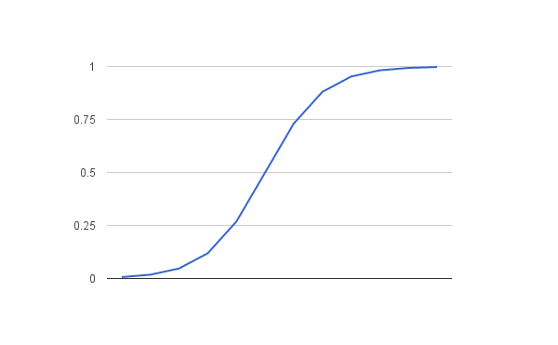

As with linear regression, we combine weights and features (w and x) along with a bias (b) to determine a predicted value ‘y’. However, as we mentioned above, the value of y will vary from 0 to 1 as a probabilistic value rather than an absolute error value. Following is an example of using the logistic regression equation with y as the predicted output, ‘b’ as the bias or y-intercept term, and w as the coefficient for the feature value x.

Logistic regression models the probability of any given data point belong to the *default* class (in other words, the first class defined).

As an example, if we were predicting the gender of a person as a dependency on their height, then the default first class could be male and the logistic regression model is defined as the probability of a person being a male depending on their height.

More formally, we can define this as:

Note that probabilities are not in and of themselves defined as binary values (0 or 1), therefore, we’ll need to transform these values into binary values in order to actually make a probability prediction.

We can transform our probability function as follows:

This can be further transformed by taking the natural logarithm ln() to both sides.

Note that this equation is now linear again, and the input on the left is now the log of the probability of the default class.

The log term on the left side of the equation is the odds of the default class. Basically it’s the ratio of probability of the event happening divided by the probability of the event not happening. Because we transform the left hand side using the natural log, we call this the *probit*, or log-odds.

We can use this to now calculate our loss function for our logistic regression example. We use an algorithm called *cross entropy*.

Cross entropy is defined as: where y is what we’re predicting and y’ is what we know to be true. We take the mean of the cross entropy as our loss value. In TensorFlow, there are a number of supplied methods that will calculate this for you.

Here is a simple example of binary classification using logistic regression.

|  |
| --- |
| #!/usr/bin/env python3  import tensorflow as tf  import numpy as np  import pandas as pd  import matplotlib.pyplot as plt  from sklearn import model_selection  import sys  gender_df = pd.read_csv('data/binary_data.csv')  # Shuffle our data  gender_df = gender_df.sample(frac=1).reset_index(drop=True)  # We'll go ahead and split the data set into training and testing parts.  # 70 per cent will go to training, the rest to testing.  train_x,test_x, train_y, test_y = model_selection.train_test_split(gender_df['HEIGHT'],gender_df['GENDER'],test_size = 0.3)  n_samples = train_x.shape[0]  # These will be the placeholders for the testing and training data  x = tf.placeholder(tf.float32)  y = tf.placeholder(tf.float32)  # Variables for the weight and bias.  W = tf.Variable(0,dtype = tf.float32)  b = tf.Variable(0,dtype = tf.float32)  # This is our activation function to determine the probability  # of our gender based on height.  activation = tf.nn.sigmoid((W * x) + b)  # Set our alpha value for the optimizer.  learning_rate = 0.001  # cross_entropy is our cost function.  cross_entropy = tf.reduce_mean(-(y*tf.log(activation) + (1 - y) * tf.log(1-activation)))  # We'll use a standard gradient descent optimizer.  train_step = tf.train.GradientDescentOptimizer(learning_rate).minimize(cross_entropy)  with tf.Session() as sess:  sess.run(tf.global_variables_initializer())  # Now train our jodel.  for epoch in range(1000):  _,l = sess.run([train_step, cross_entropy], feed_dict = {x: train_x, y:train_y})  if epoch % 50 == 0:  print ('loss = %f' %(l))  # Now let's see how our model performed on the test data.  correct = tf.equal(tf.argmax(activation,1), tf.argmax(y,1))  accuracy = tf.reduce_mean(tf.cast(correct,'float'))  print ('Accuracy: ', sess.run(accuracy,feed_dict = {x: test_x, y:test_y})) |

# Multiclassification with Logistic Regression.

Whereas the last example only contained two classifications, male and female, many classifications divide data into more than two classes. A classic example of this is the MNIST image database. This is a well known data store of 55,000 greyscale images of 28 X 28 pixels that contain hand drawn digits from zero to nine. We can use logistic regression to predict what value is represented by an image.

Let’s see how this will work. First, we’ll convert each image from a 28 X 28 two dimensional image into a one dimensional image of 784 values ranging from 0 (White) to 255 (black). Other values represent various shades of grey.

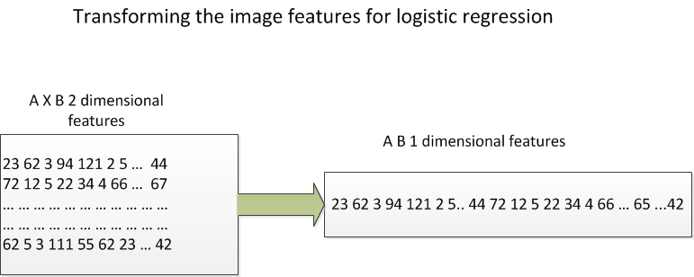

This is known as *matrix unrolling*.

Our prediction needs to be in the values from zero to nine, which means that we have to convert the probabilities (say, for example 2.3 or 11) into something in the range of the classes [0 – 9]

To fix this, we have a prediction vector y, which is a single column vector. Each element in this vector represents the score of what the logistic regression model thinks is likely to be a particular class. In the exampke below class ‘1’ is the prediction since it has the highest score.

[ 1.3 33 2 1.2 3.2 0.5 3 9.2 2 1 1]

Where the score (probability) for class 0 is 1.3, the score for class 1 is 33 and so on.

How do we get this vector? Each pixel provides its own score for each class, i.e. pixel 0 will provide what it thinks is the most likely class that the image belongs to, pixel 1 will do the same, and so on up to pixel 768.

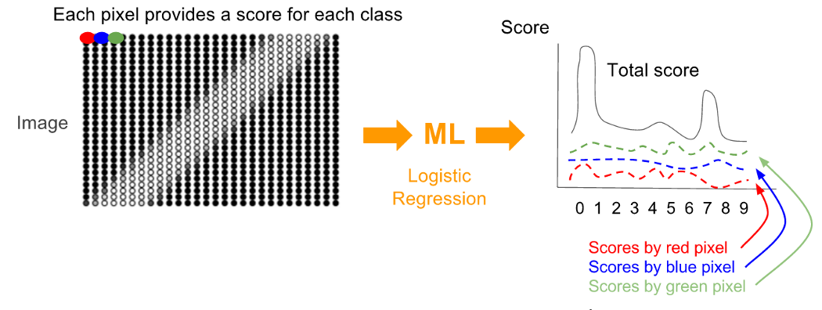

Now, for each score, we have to find out how badly or well the algorithm’s prediction was. However, we can’t use a standard linear regression loss function. Those compute *magnitudes* of error. In our case, it doesn’t matter what the magnitude is, error is error whether it’s a small or a large value. We’ll use a different type of loss function, called the *cross-entropy* function.

This function has multiple steps.

1. One-hot vectors

We’ve gone ahead and transformed our prediction (y) into a vector of scores, we should also transform the actual image class values into a vector as well so that we can compare each element (pixel) in the predicted with the actual value. Each element in the actual value vector will be ‘0’ except for the value that corresponds to the actual number drawn in the image. So, for example, an image of 2 will have a one-hot vector that looks like this:

[0 0 1 0 0 0 0 0 0]. Let’s see a plot of the comparison between the predicted value vector and the actual value vector.

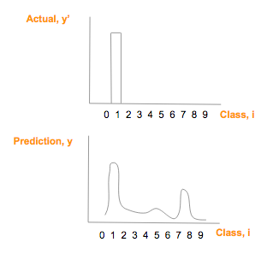

1. Calculate the probability distribution using the softmax algorithm.

Using the cross entropy will allow us to compare the similarity of two graphs. To do this, however, we need to convert both the actual outcome vector (y’) and the predicted outcome vector (y) into a probability distribution. By this we mean

* The probability score of each class has to be between 0 and 1.
* The sum of all the probabilities/scores for each class has to be 1.

The outcome vector, being a one-hot vector already meets these constraints, however, we need to transform the prediction vector into a probability distribution using softmax. The softmax algorithm looks like this:

Where I is the class, in this case of 0, 1,2, …9. Every element of the prediction score is exp’d and then divided by the sum of the exp’d total.

Here’s a graph of the softmax values after transformation.

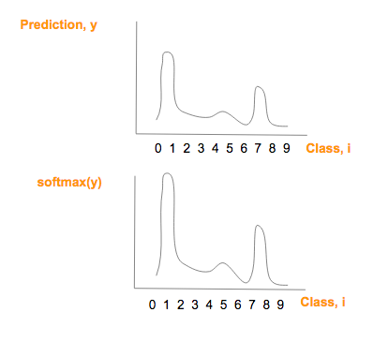

Note that the graphs are similar, except that the softmax values having a larger maximum value and a smaller minimum value.

Now we can apply the cross-entropy formula to the softmax transformed prediction vector.

The cross entropy formula is as follows:

This formula will calculate our loss as we run our optimizing function.

Let’s now see what our transformed prediction vector looks like graphically.

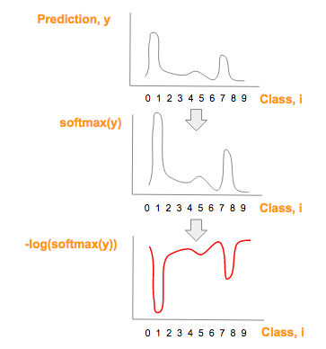

Now, we can simply multiply our actual probabilities as referenced by our one hot vector vs. the predicted values. Note that since all values in the one-hot vector other than the actual value are zero, the multiplication gives us a 1 value in the right position (hopefully) for the predicted value vector.

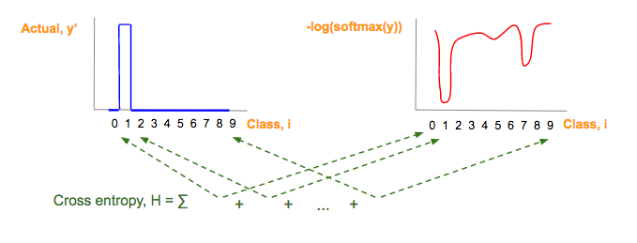

# Introduction to Neural Networks with the Perceptron

In this module, we introduction the concept of artificial neural networks (ANNs) and the perceptron, which is a type of node in an ANN. ANNs work very differently than most type of programming logic. Instead of applying a set of rules in order to tell a computer what to do, the ANN allows the computer to learn on its own in order to achieve an optimum result.

We use ANNs for many different purposes. For example:

* Data classification, for example image recognition. Is the picture of a dog or a cat?
* Anomaly detection. Is this seismic activity showing signs of an earthquake about to happen?
* Predictions and approximations. Will this storm turn into a hurricane?

There are many different types of ANN’s, but the general structure of an ANN looks something like this:

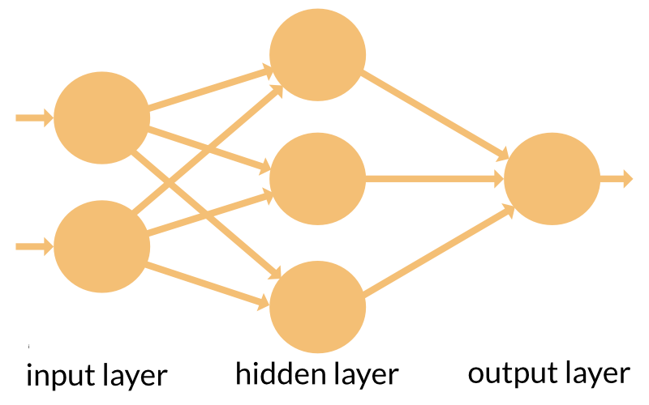

ANNs can have one or more nodes in the input layer, one or more hidden layers (A neural network with multiple hidden layers is known as a *deep* neural network), and an output layer.

Neural networks are not programmed or configured to perform a specific task, instead, they are *trained* to do so, in the same fashion that a human brain is trained to perform a specific skill.

There are three general types of training that a neural network can undergo.

1. Supervised learning. If we have a large enough set of test data with known results, then we can feed a dataset into the neural network to train it. We can then compare the trained output with the actual output. Adjust the network and repeat until a satisfactory result is achieved.
2. Unsupervised learning. If we don’t have any known test data, and if we can figure out some sort of cost function from our desired behavior, i.e. cost function of 0 means that the unsupervised neural network doesn’t drive the car off the road, for example, then the network can adjust its parameters on the fly while it works on the real production data.
3. Reinforced learning. Also known as the *carrot and stick* approach. This can be used if the ANN generates continuous action. I.e. Follow the carrot in front of your nose. If the ANN goes the wrong way, then penalize it. Over time, the ANN learns to prefer the right kind of action and avoid the wrong kind.

The basic ingredient of a neural network is the *neuron* or neural network node. This neuron works very similarly in concept to a neuron in the human brain. A neuron has one or more input channels, a processing stage and an output that can fan out to other neurons. Here is a simple conceptual diagram of a neuron in an ANN vs. a biological neuron.

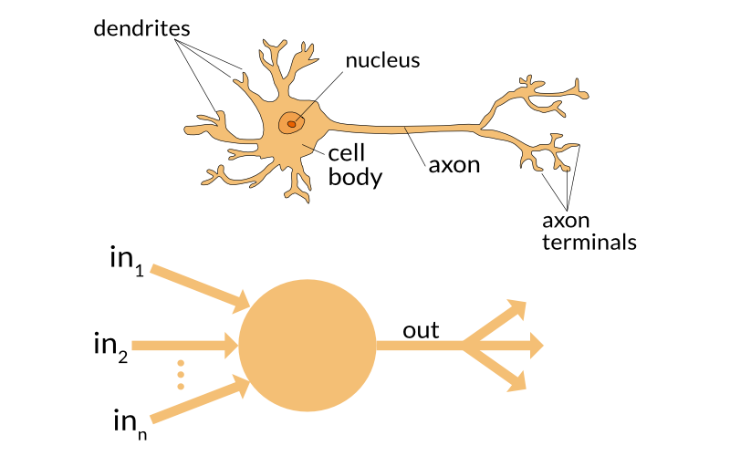

Let’s take a closer look at the artificial neuron.

There are three basic steps to an artificial neuron.

1. Each input gets scaled up or down. When a signal comes in, it gets multiplied by a *weight* value that is assigned o that particular input. I.e. if a neuron has three inputs, then it has three different weights, one for each input. Each weight can be adjusted individually. The learning phase consists of the neural network adjusting each weight based on the error of the last test results.
2. All of the signals are summed up. All of the modified input signals are summed up to a single value, including a bias value which is added to the sum. The bias, as well as the weights, is adjusted during the learning phase. When an ANN is first defined, we set the weights and biases to random numbers. After each training iteration, the weights and biases are gradually changed so that the next result is close to the desired outcome. This is the “learning” portion of the ANN training.
3. Finally, the results of the summing up is turned into an output signal which is created by feeding this summed value into an activation function which outputs a results which can be sent to another node in the network.